*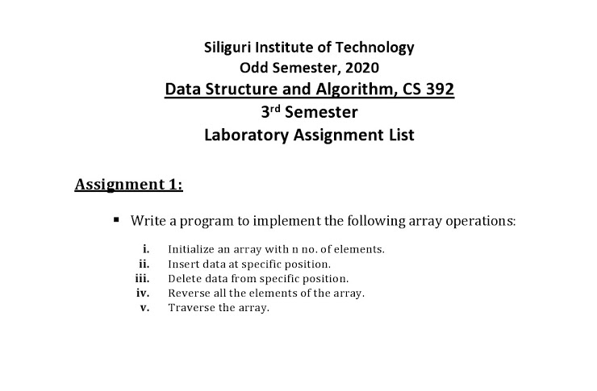****Program –***

#include<stdio.h>

#include<stdlib.h>

void reverse(int* ,int);

void enterData(int* ,int);

void delData(int* ,int);

void traverse(int* ,int);

int main()

{

int n, ch;

printf("Enter size of array: ");

scanf("%d",&n);

int arr[n]; // array initilization

printf("Enter data:\n");

for(int i=1; i<=n; i++)

scanf("%d",&arr[i]);

while(1)

{

printf("1.Insert Data\n");

printf("2.Delete Data\n");

printf("3.Reverse array\n"); printf("4.Traverse\n");

printf("5.Exit\n");

printf("Enter your choice: ");

scanf("%d",&ch);

switch(ch)

{

case 1: enterData(arr, n);

break;

case 2: delData(arr, n);

break;

case 3: reverse(arr, n);

break;

case 4: traverse(arr, n);

break;

case 5: exit(1);

default:printf("Invalid choice!\n\n");

}

}

return 0;

}

void enterData(int *arr, int n)

{

int pos, data;

printf("Enter position to enter data: "); scanf("%d",&pos);

printf("Enter data: ");

scanf("%d",&data);

arr[pos] = data;

for(int i=1; i<=n; i++)

printf("%d ",arr[i]);

printf("\n\n");

}

void delData(int *arr, int n)

{

int pos;

printf("Enter position to delete data from: "); scanf("%d",&pos);

arr[pos] = 0;

for(int i=1; i<=n; i++)

printf("%d ",arr[i]);

printf("\n\n");

}

void reverse(int *arr, int n)

{

printf("Reverse of the array is:\n");

for (int i=n; i>=1; i--)

printf("%d ",arr[i]);

printf("\n\n");

}

void traverse(int *arr, int n)

{

for(int i=1; i<=n; i++)

printf("%d ",arr[i]);

printf("\n\n");

}